Design Doc Template

*Author(s): M.Srija, D. Sai Sowmya, K.Bhavya Sri, D.Neelima*

*Date: 23/05/2019*

Revision: 0

Document Status: Draft [Draft, Completed, Submitted, Reviewed, Final]

Project Status: In-Progress [In Review, Approved, In-Progress, Completed]

Revision History

|  |  |  |  |
| --- | --- | --- | --- |
| Date | Revision | Description | Author |
| 23/05/2019 | 0 | Initial draft of the design doc template |  |
|  |  |  |  |
|  |  |  |  |
|  |  |  |  |
|  |  |  |  |
|  |  |  |  |
|  |  |  |  |
|  |  |  |  |
|  |  |  |  |
|  |  |  |  |

Table of Contents

TOC \o "1-3" \h \z \u Introduction4

Summary4

Background4

Definitions, Acronyms, and Abbreviations4

Design Overview4

Requirements4

Documentation4

M-inimum Viable Product5

Stretch goals5

Future work5

Architectural Diagrams5

System Diagrams5

Application Programming Interface5

Recommendations5

User Interface6

Data Models and Storage6

Service Operability6

Key Performance Indicators6

Service Level Objectives6

Project Overview7

Communication and Tracking7

Risks7

Milestones7

Project Phases7

Cost7

Frequently Asked Question7

References7

Addendum8

# Introduction

## Summary

Our project mainly focuses on the remote areas. We will take the information from the people who came to diagnose eyes through our equipment. By taking the images of their eyes, we will check whether their eyes are healthy or they are affected by any specific disease. Then we forward the information to the nearby hospitals in collaboration with us who treat these diseases. After the verification by the doctor this information is send to the place where the diagnosis is done as well as a message is sent to the patient.

Non-technical project overview, also known as an executive summary or elevator pitch. Intended to quickly summaries the problem you are trying to solve.

## Background

The problem statement, what are the issues you are trying to solve, what gaps currently exist, etc.

We are actually trying to diagnose the eyes of the people in the remote places as soon as possible so that the treatment to the disease can be done in the earlier stages without the spread of the disease.

What are the existing tools that address these issues or gaps, and why do they not satisfy this problem? Why can’t the existing tools be updated to solve this problem.

The existing methods need the physical presence of the patients in the hospitals where they use slit lamp setup to identify the diseases. They don’t satisfy this problem because of lack of this equipment in the rural areas which are costly.

Yes, we are updating the existing one by adding some extra features like image processing.

What overlaps will your solution have and how is it differentiated from the existing tooling

It is different from the existing tool that it can be used compatibly even in the remote places where people can easily approach

What are the gains / wins from creating this tool / solution?

There will be easy connectivity between the patient in the remote areas and the doctor even if he is far away from the

## Definitions, Acronyms, and Abbreviations

Definition of terms that will help readers understand the documents, or acronyms common in your project area

# Design Overview

## Requirements

Project requirements, this can include requirements from customers, partners, or overseeing teams. The requirements for the project, this may include subsections for various types or sources of requirements

We require the correct details of the customers; technician who can operate our equipment; collaboration with various hospitals

### Documentation

If the project requires any wiki pages, code comments, presentations, etc. that information should be included here

## Minimum Viable Product

A detailed description of the deliverable for this project, this is the minimal functionality required for the project to be considered successful and should not include stretch goals or future work.

## Stretch goals

Stretch goals include functionality beyond the scope of the minimum viable product that should be include in the project should time and budget permit. Unlike future work, stretch goals would be smaller tasks for features in support of the minimum viable product.

## Future work

This may include ongoing support, expansion of the original scope, work that requires transitions in project ownership, or details of projects designed to be broken up into multiple phases.

# Architectural Diagrams

UML diagrams describing the project. You can look for any open source diagramming tool for the same.

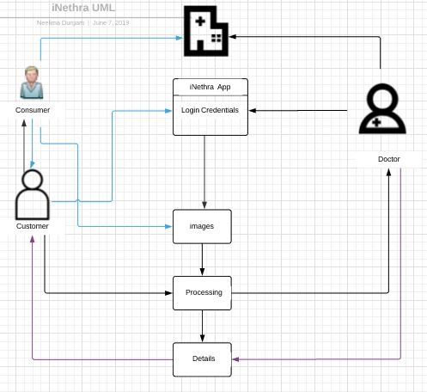

# System Diagrams

This section, sometimes referred to as a ‘System Context Diagram’, would typically consist of a UML diagram which illustrates the boundary and interaction with external systems. For a CLI this may show which backend systems provide the data, for services it may indicate dependencies such as databases, Kafka, or downstream services.

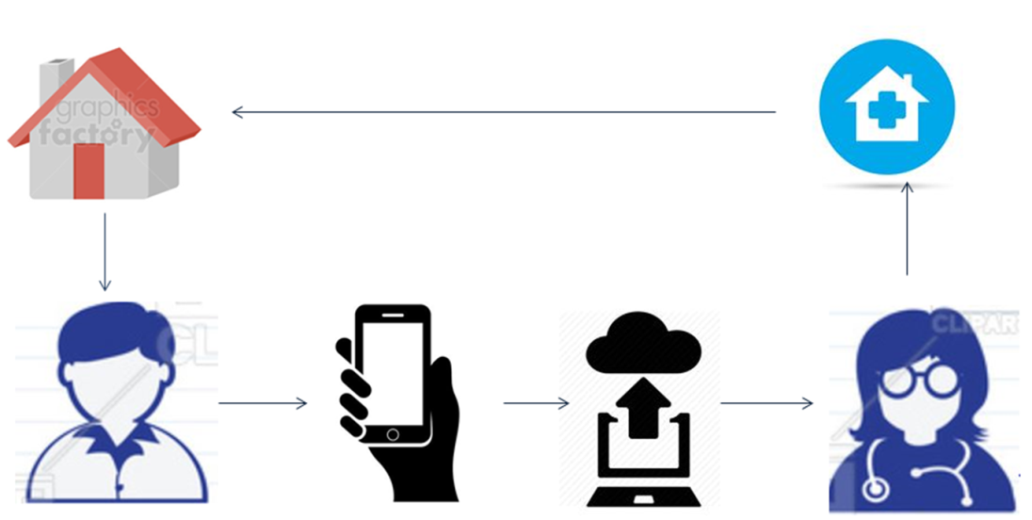

# Application Programming Interface

For services, libraries, and command line interfaces that present an interface which can be wrapped

## Recommendations

Using a versioned endpoint simplifies the process of making future backwards incompatible API changes;

/api/v0

# User Interface

For frontends, a mockup can be attached to illustrate the user interface. Command line interfaces may include a list of subcommands and their options.

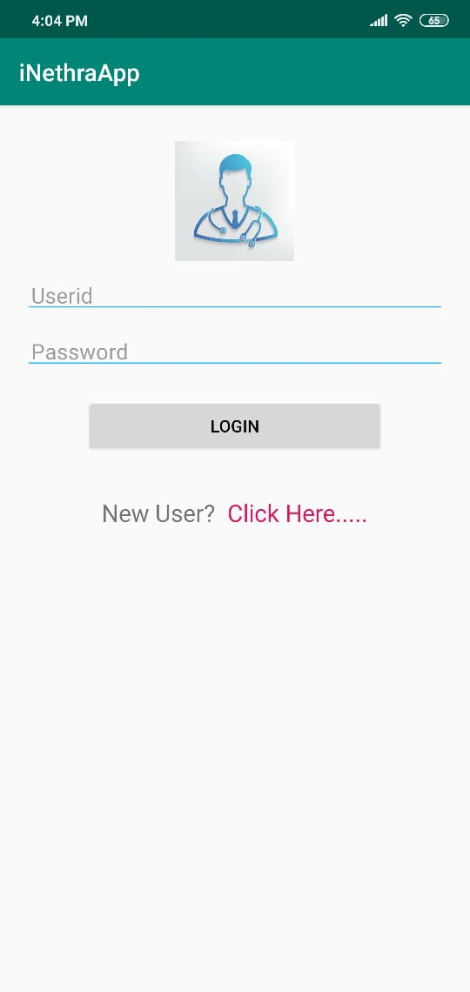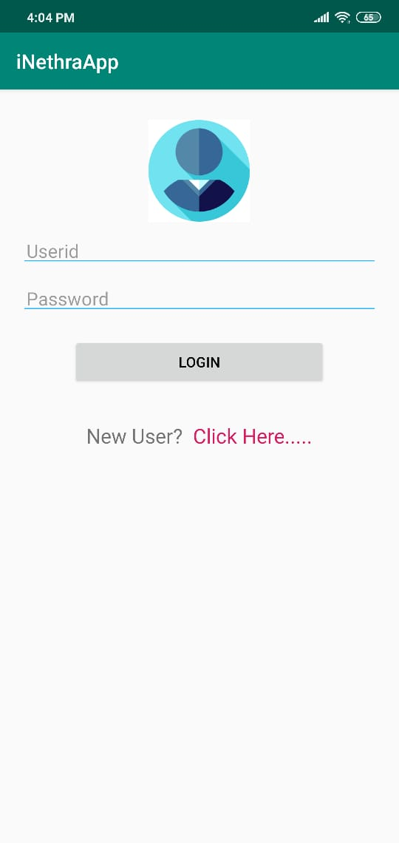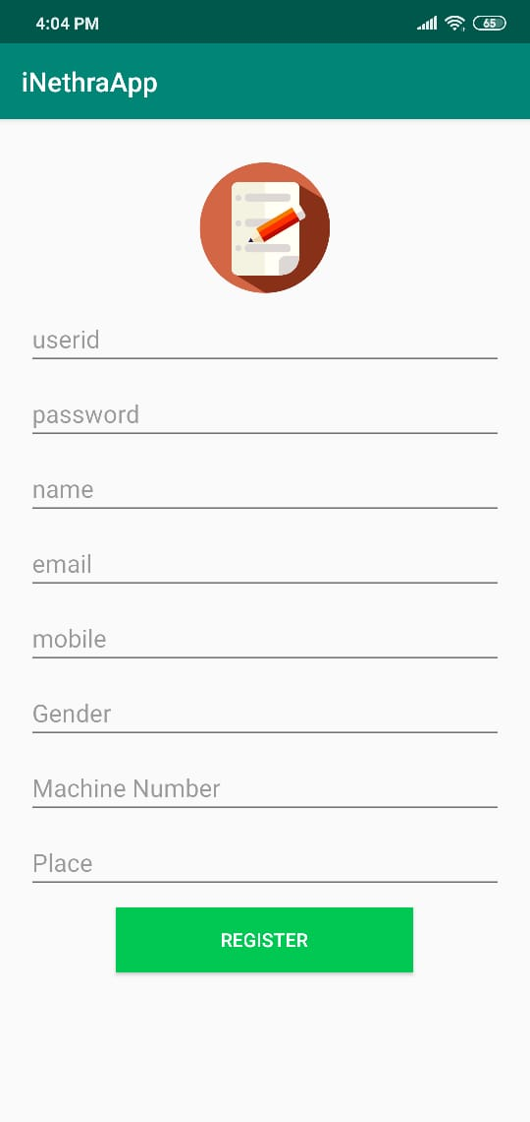

# Data Models and Storage

For projects requiring messages queue such as Kafka, MySQL, etc.

Kafka

* How many partitions are needed for this topic?
* How many days of retention will be needed?
* What will the partitioning key become?
* How much data will be written to the topic during peak hours?
* What type of Kafka cluster will be needed? (E.g. aggregate, queuing, tracking, metrics, logging)

MySQL

* What does the table schema look like and how are they all tied together (provide a UML)?
* What sort of updates will be made to the tables?
* How will users make queries to the tables? (e.g. Complex joins, pre-filtering, single record gets)
* What the strategy for indexing?

# Service Operability

## Key Performance Indicators

Key performance indicators (KPI), describe how a service should be monitored and how its performance can be gauged. This would typically include an overview of the types of metrics an application will need to emit, call time, error rate, etc.

## Service Level Objectives

Service level objectives (SLOs), set targets for various KPI through alerts via email or SMS, these targets may provide early indicators of approaching a capacity limit, changes in load patterns through various phases of an application, changes in duration of offline processing, etc.

# Project Overview

## Communication and Tracking

Any relevant distribution lists, slack channels, taiga projects, etc

Our channels are the eye care centers and eye clinics through which our products generates revenue. We will send our devices to these clinics and eye care centers and the patients come there for eye checkup . We will also do an online business model through which customers can buy our device.

## Risks

Anything that may put the project at risk; potential delays, dependence on work done by other teams, hardware procurement, or reviews.

Risks may also include assumptions of the project's external dependencies. These may be lower level project dependencies that are tracked outside of the immediate project scope and assumed to already be in place. For example, "project x assumes OS version y will be available in the market."

Our main risk involved is that another company in the market is also doing a similar kind of application but with a tablet whereas we are doing it with a smart phone

Our device requires a 20D condensing lens. But the condensing lenses are not easily available in the market. This leads to a risk of timely manufacturing of the device.

## Milestones

Estimated dates when planning steps, deliverables, and reviews will be completed

Our estimated time of completion of the product was 2 weeks but due to the delay of the arrival of the lens, it took 3 weeks

We are also designing an app which stores all the details of the patients which was reviewed and suggested by our mentor

## Project Phases

For projects that are better tracked and reported on in multiple phases because of extended timelines, external dependencies, etc

First our device was designed so that it uses only a 20D condensing lens and a smart phone

Then after checking the device , there araised a need of other set of lenses consisting of double convex , 2 concave lenses so as to get a clear and magnified images of the eyes

## Cost

Level of effort, number of resources, number of hours or weeks, unlike milestones which tracks project time cost should only include engaged time.

1) For the all tasks which are deliverables/visible on user-end side needs to be documented as stories.

2) Need to guess/estimate the time required in number of hours for the completing that stories which can be captured in taiga.

3) Assign that task to the right person and document the actual time taken for completing that task.

# Frequently Asked Question

# References

Links to any supporting documentation, other projects, or reference material

# Addendum

Additional diagrams or details that do not particularly belong in the body of the design doc. This could also be a place to describe additional examples that would otherwise bloat the introduction section. More specifics on APIs could also be placed here for engineers to reference.